CEL 51, DCCN, Monsoon 2020

Lab 7: RIPv2 Router Configuration

**Topology Diagram**

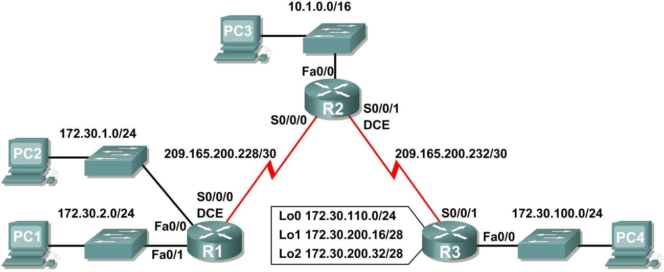

**Addressing Table**

|  |  |  |  |  |
| --- | --- | --- | --- | --- |
| **Device** | **Interface** | **IP Address** | **Subnet Mask** | **Default Gateway** |
| **R1** | **Fa0/0** | 172.30.1.1 | 255.255.255.0 | N/A |
| **Fa0/1** | 172.30.2.1 | 255.255.255.0 | N/A |
| **S0/0/0** | 209.165.200.230 | 255.255.255.252 | N/A |
| **R2** | **Fa0/0** | 10.1.0.1 | 255.255.0.0 | N/A |
| **S0/0/0** | 209.165.200.229 | 255.255.255.252 | N/A |
| **S0/0/1** | 209.165.200.233 | 255.255.255.252 | N/A |
| **R3** | **Fa0/0** | 172.30.100.1 | 255.255.255.0 | N/A |
| **S0/0/1** | 209.165.200.234 | 255.255.255.252 | N/A |
| **Lo0** | 172.30.110.1 | 255.255.255.0 | N/A |
| **Lo1** | 172.30.200.17 | 255.255.255.240 | N/A |
| **Lo2** | 172.30.200.33 | 255.255.255.240 | N/A |
| **PC1** | **NIC** | 172.30.2.10 | 255.255.255.0 | 172.30.2.1 |
| **PC2** | **NIC** | 172.30.1.10 | 255.255.255.0 | 172.30.1.1 |
| **PC3** | **NIC** | 10.1.0.10 | 255.255.0.0 | 10.1.0.1 |
| **PC4** | **NIC** | 172.30.100.10 | 255.255.255.0 | 172.30.100.1 |

1 of 58

**Learning Objectives**

Upon completion of this lab, you will be able to:

* Cable a network according to the Topology Diagram.
* Load provided scripts onto the routers.
* Examine the current status of the network.
* Configure RIPv2 on all routers.
* Examine the automatic summarization of routes.
* Examine routing updates with **debug ip rip**.
* Disable automatic summarization.
* Examine the routing tables.
* Verify network connectivity.
* Document the RIPv2 configuration.

**Scenario**

The network shown in the Topology Diagram contains a discontiguous network, 172.30.0.0. This network has been subnetted using VLSM. The 172.30.0.0 subnets are physically and logically divided by at least one other classful or major network, in this case the two serial networks 209.165.200.228/30 and 209.165.200.232/30. This can be an issue when the routing protocol used does not include enough information to distinguish the individual subnets. RIPv2 is a classless routing protocol that can be used to provide subnet mask information in the routing updates. This will allow VLSM subnet information to be propagated throughout the network.

# Task 1: Cable, Erase, and Reload the Routers.

## Step 1: Cable a network.

Cable a network that is similar to the one in the Topology Diagram.

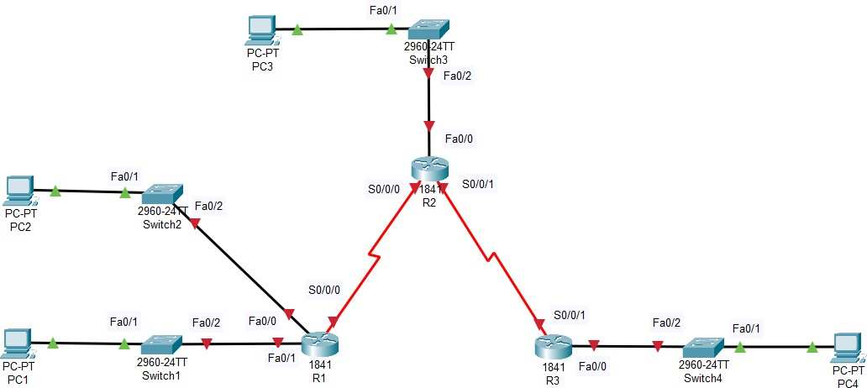

Figure 7.1 – The network in the design area similar to the one in the above diagram

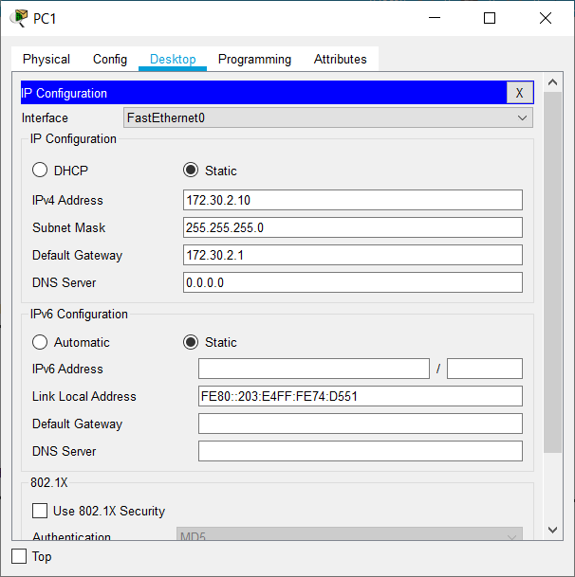

Figure 7.2 – The IP Configuration of PC1 according to given addressing table

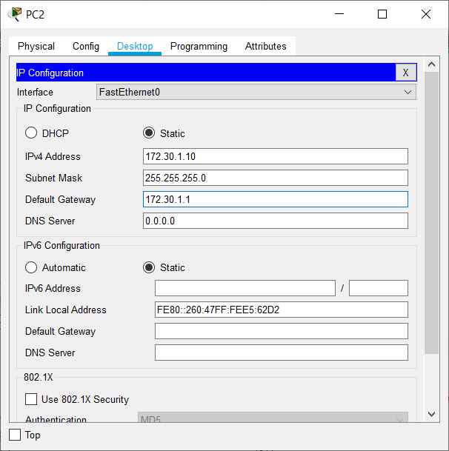

Figure 7.3 – The IP Configuration of PC2 according to given addressing table

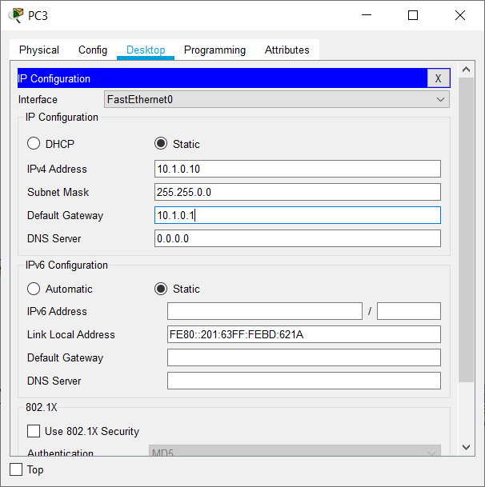

Figure 7.4 – The IP Configuration of PC3 according to given addressing table

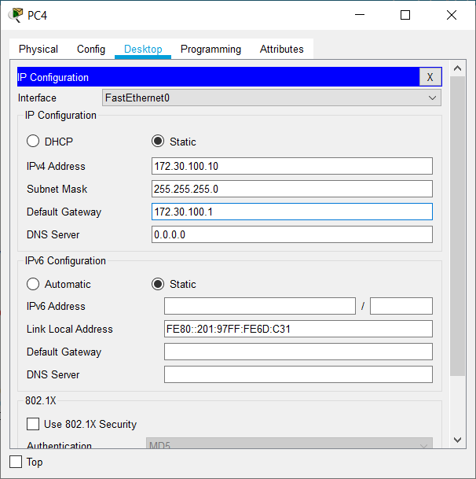

Figure 7.5 – The IP Configuration of PC4 according to given addressing table

## Step 2: Clear the configuration on each router.

Clear the configuration on each of routers using the **erase startup-config** command and then

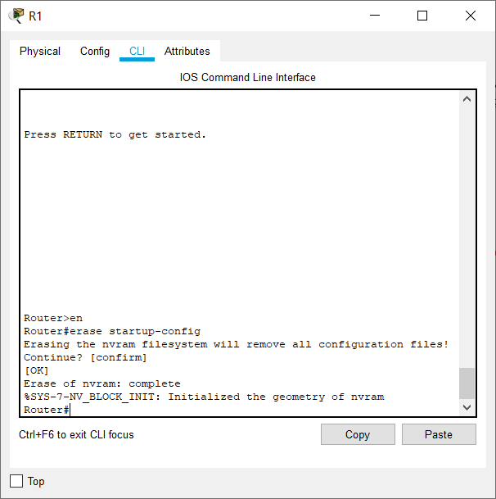**reload** the routers. Answer **no** if asked to save changes.

Figure 7.6 – Erasing the startup configuration of Router R1

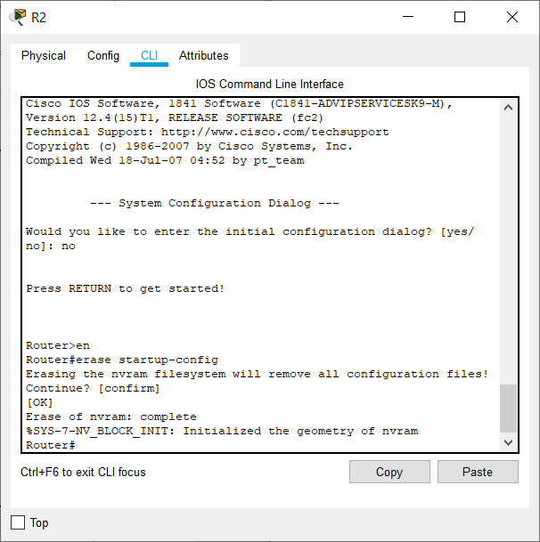

Figure 7.7 – Erasing the startup configuration of Router R1

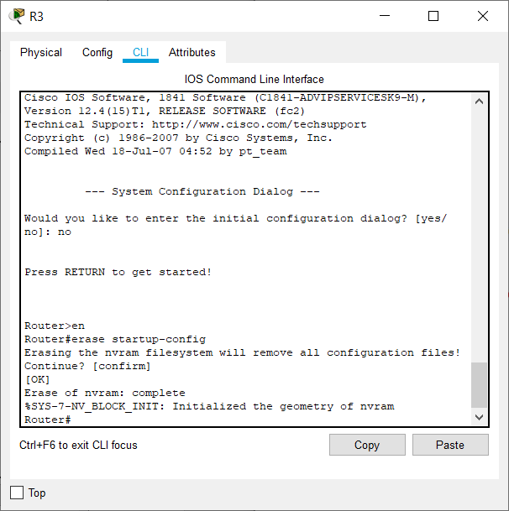

Figure 7.8 – Erasing the startup configuration of Router R3

# Task 2: Load Routers with the Supplied Scripts.

## Step 1: Load the following script onto R1.

!

hostname R1

!

!

!

interface FastEthernet0/0

ip address 172.30.1.1 255.255.255.0

duplex auto speed auto no shutdown

!

interface FastEthernet0/1

ip address 172.30.2.1 255.255.255.0

duplex auto speed auto no shutdown

!

interface Serial0/0/0

ip address 209.165.200.230 255.255.255.252

clock rate 64000 no shutdown

!

router rip

passive-interface FastEthernet0/0 passive-interface FastEthernet0/1 network 172.30.0.0

network 209.165.200.0

!

line con 0

line vty 0 4 login

!

end

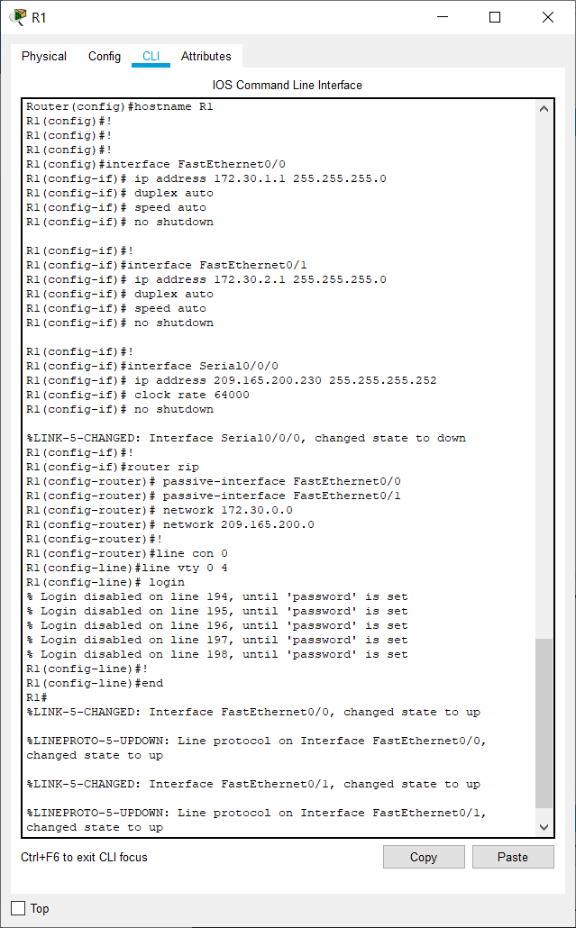

Figure 7.9 – Loading router R1 with the given script

## Step 2: Load the following script onto R2.

hostname R2

!

!

!

interface FastEthernet0/0

ip address 10.1.0.1 255.255.0.0 duplex auto

speed auto no shutdown

!

interface Serial0/0/0

ip address 209.165.200.229 255.255.255.252

no shutdown

!

interface Serial0/0/1

ip address 209.165.200.233 255.255.255.252

clock rate 64000 no shutdown

!

router rip

passive-interface FastEthernet0/0 network 10.0.0.0

network 209.165.200.0

!

line con 0

line vty 0 4 login

!

end

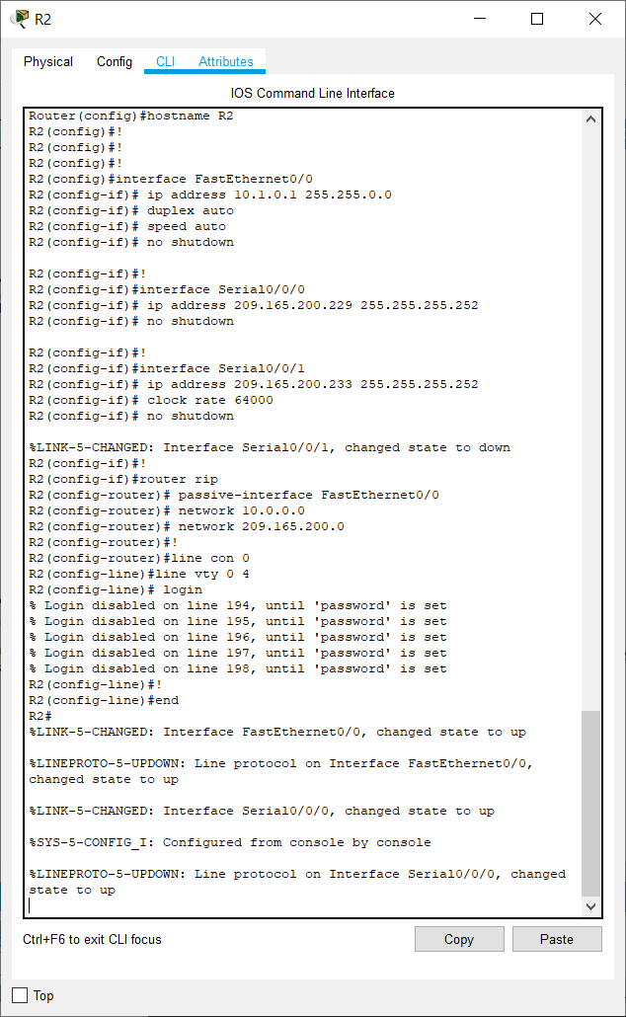

Figure 7.10 – Loading router R2 with the given script

## Step 3: Load the following script onto R3.

hostname R3

!

!

!

interface FastEthernet0/0

ip address 172.30.100.1 255.255.255.0

duplex auto speed auto no shutdown

!

interface Serial0/0/1

ip address 209.165.200.234 255.255.255.252

no shutdown

!

interface Loopback0

ip address 172.30.110.1 255.255.255.0

!

interface Loopback1

ip address 172.30.200.17 255.255.255.240

!

interface Loopback2

ip address 172.30.200.33 255.255.255.240

!

router rip

passive-interface FastEthernet0/0 network 172.30.0.0

network 209.165.200.0

!

line con 0

line vty 0 4 login

!

end

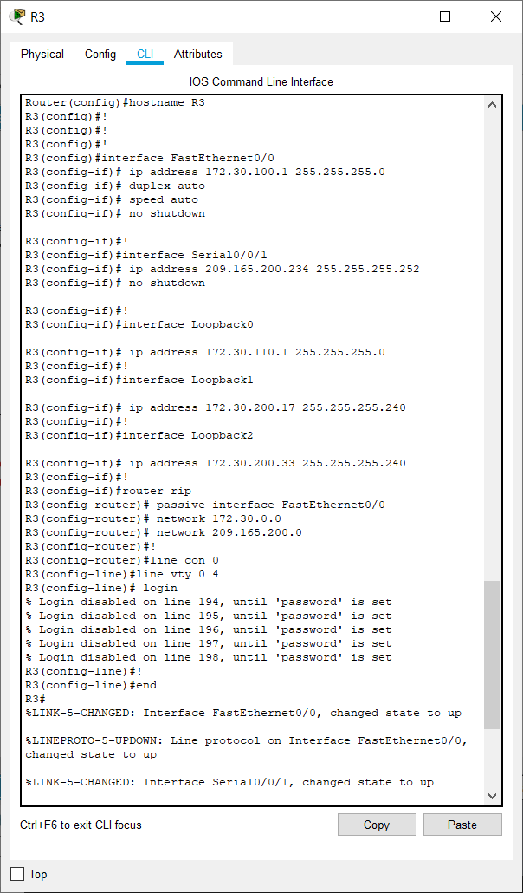

Figure 7.11 – Loading router R2 with the given script

# Task 3: Examine the Current Status of the Network.

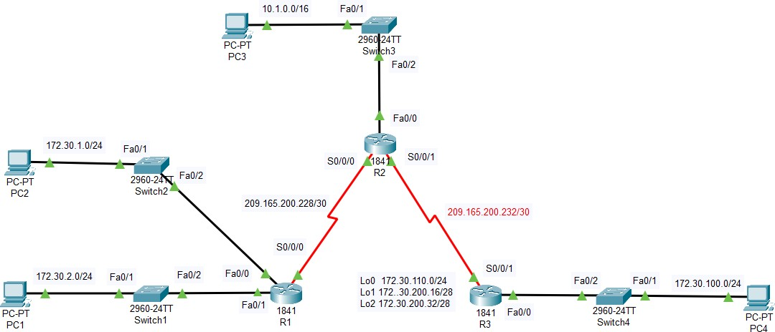

Figure 7.12 – The network in the design area after the configuration of routers.

## Step 1: Verify that both serial links are up.

The two serial links can quickly be verified using the **show ip interface brief** command on R2.

## R2#show ip interface brief

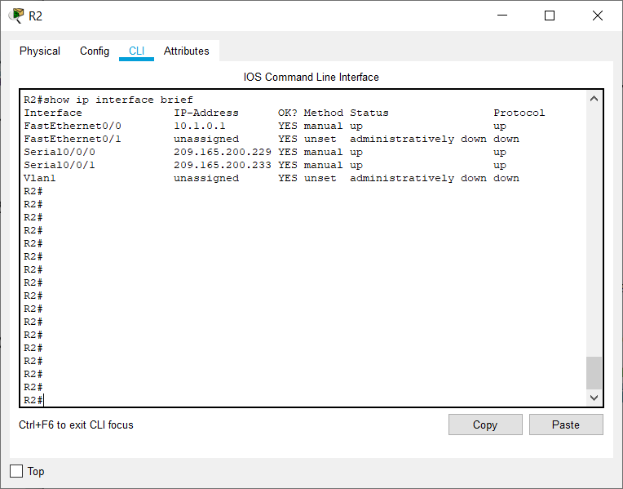

Figure 7.13 – The serial connections for R2 are up and running as visible in this picture

## Step 2: Check the connectivity from R2 to the hosts on the R1 and R3 LANs.

Note: For the 1841 router, you will need to disable IP CEF to obtain the correct output from the **ping** command. Although a discussion of IP CEF is beyond the scope of this course, you may disable IP CEF by using the following command in global configuration mode:

R2(config)#**no ip cef**

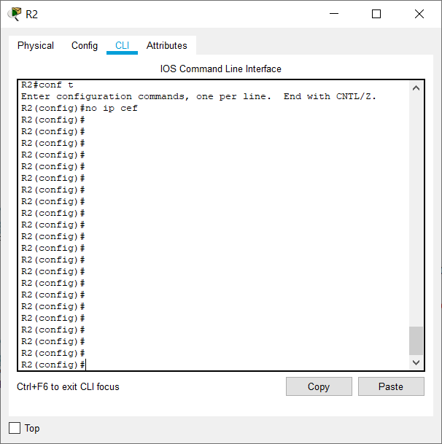

Figure 7.14 – Applying no ip cef command on the router R2

From the R2 router, how many ICMP messages are successful when pinging PC1? 2 out of 5 ICMP messages are successful when pinging PC1.

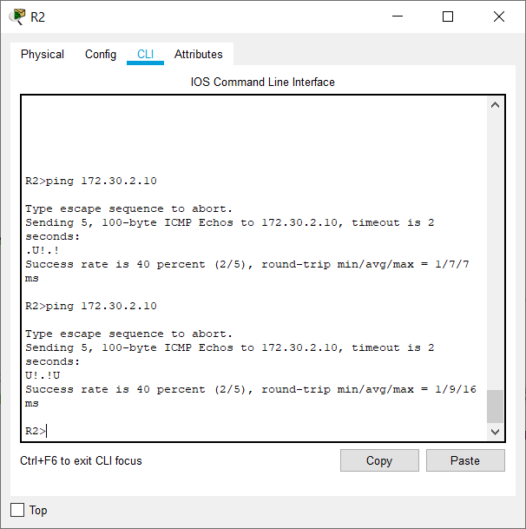

Figure 7.15 – Pinging PC1 from router R2

From the R2 router, how many ICMP messages are successful when pinging PC4? On an average, 2 out of 5 ICMP messages are successful when pinging PC4.

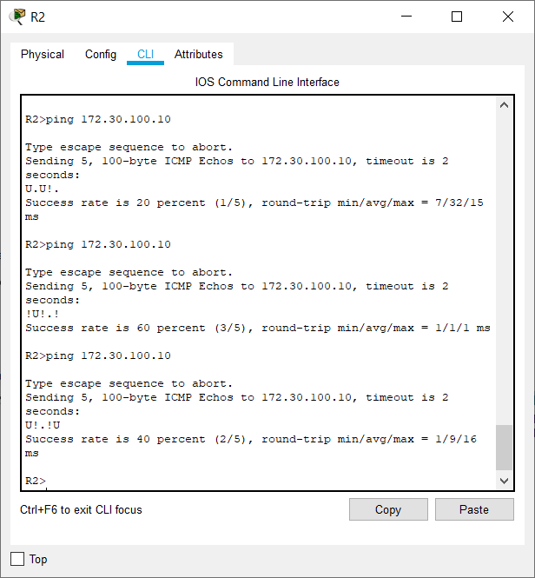

Figure 7.16 – Pinging PC4 from router R2

## Step 3: Check the connectivity between the PCs.

From the PC1, is it possible to ping PC2? Yes

What is the success rate? 75% once and then 100%

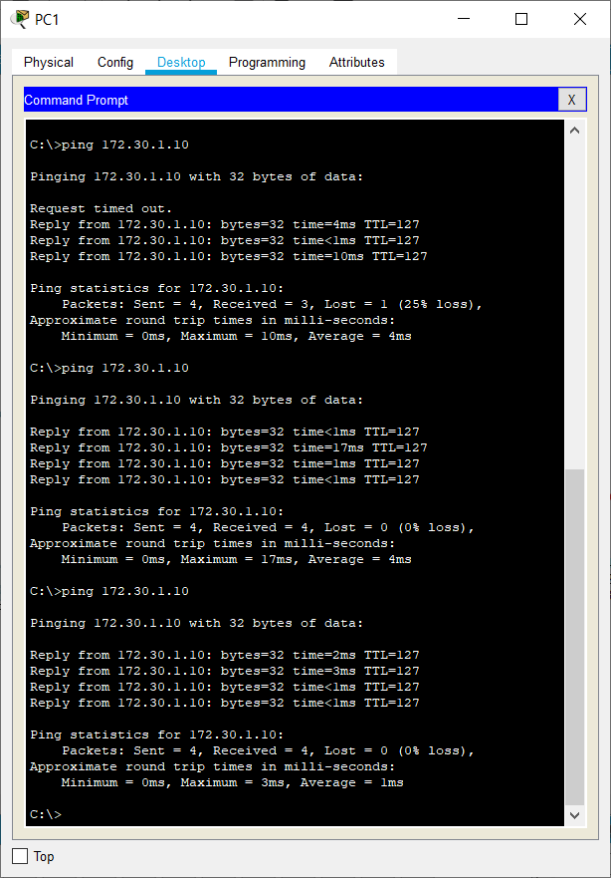

Figure 7.17 – Pinging from PC1 to PC2

From the PC1, is it possible to ping PC3? Yes What is the success rate? 25% once and then 50%

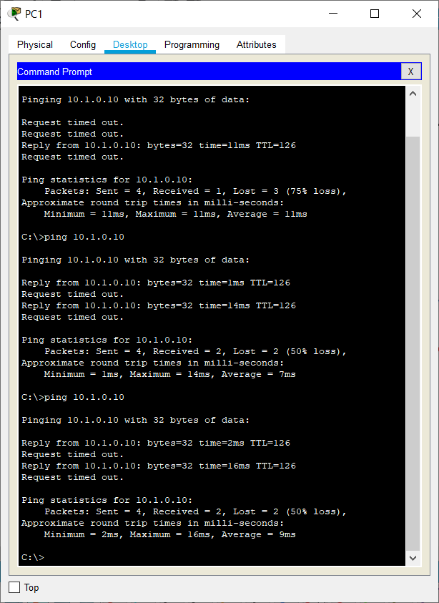

Figure 7.18 – Pinging from PC1 to PC3

From the PC1, is it possible to ping PC4? No What is the success rate? 0%

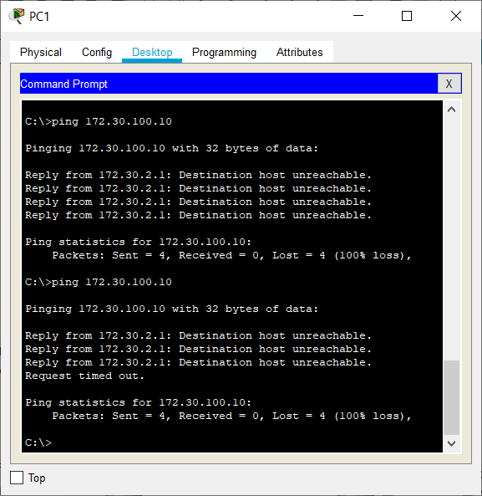

Figure 7.19 – Pinging from PC1 to PC4 From the PC4, is it possible to ping PC2? No

What is the success rate? 0%

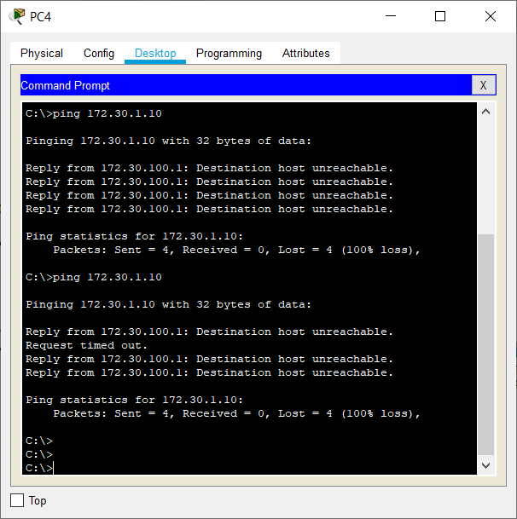

Figure 7.20 – Pinging from PC4 to PC2

From the PC4, is it possible to ping PC3? Yes What is the success rate? 50%

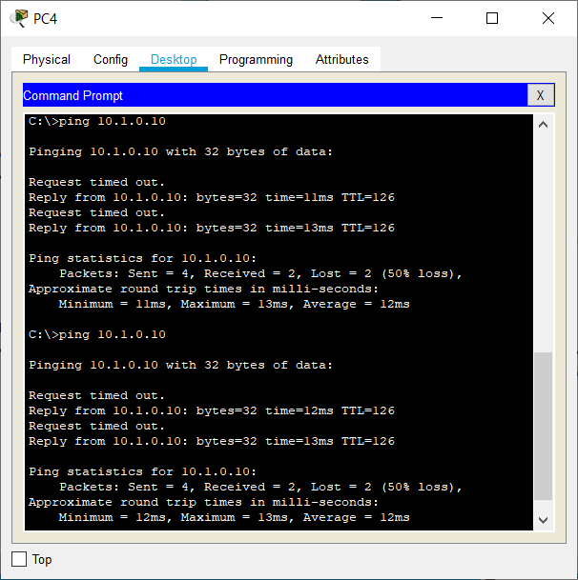

Figure 7.21 – Pinging from PC4 to PC3

## Step 4: View the routing table on R2.

Both the R1 and R3 are advertising routes to the 172.30.0.0/16 network; therefore, there are two entries for this network in the R2 routing table. The R2 routing table only shows the major classful network address of 172.30.0.0—it does not show any of the subnets for this network that are used on the LANs attached to R1 and R3. Because the routing metric is the same for both entries, the router alternates the routes that are used when forwarding packets that are destined for the 172.30.0.0/16 network.

## R2#show ip route

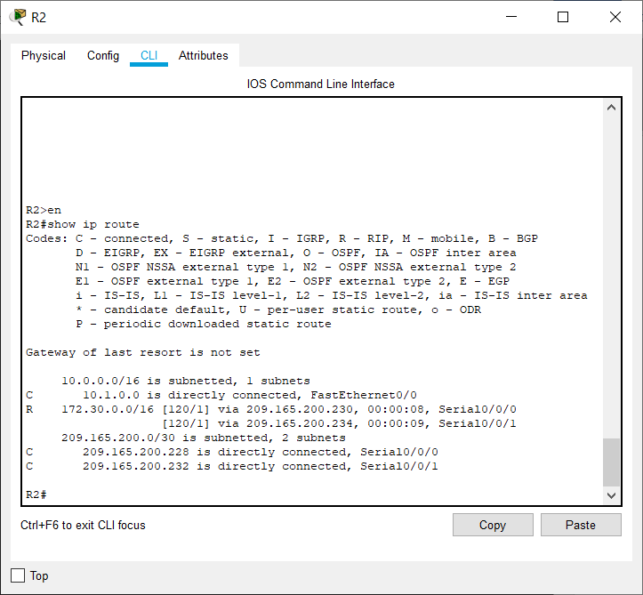

Figure 7.22 – Shows the IP routes of router R2

## Step 5: Examine the routing table on the R1 router.

Both R1 and R3 are configured with interfaces on a discontiguous network, 172.30.0.0. The 172.30.0.0 subnets are physically and logically divided by at least one other classful or major network—in this case, the two serial networks 209.165.200.228/30 and 209.165.200.232/30. Classful routing protocols like RIPv1 summarize networks at major network boundaries. Both R1 and R3 will be summarizing 172.30.0.0/24 subnets to 172.30.0.0/16. Because the route to 172.30.0.0/16 is directly connected, and because R1 does not have any specific routes for the 172.30.0.0 subnets on R3, packets destined for the R3 LANs will not be forwarded properly.

## R1#show ip route

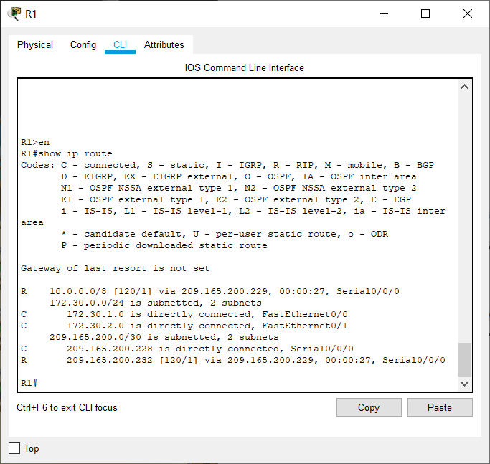

Figure 7.23 – Shows the IP routes of router R1

## Step 6: Examine the routing table on the R3 router.

R3 only shows its own subnets for 172.30.0.0 network: 172.30.100/24, 172.30.110/24, 172.30.200.16/28, and 172.30.200.32/28. R3 does not have any routes for the 172.30.0.0 subnets on R1.

## R3#show ip route

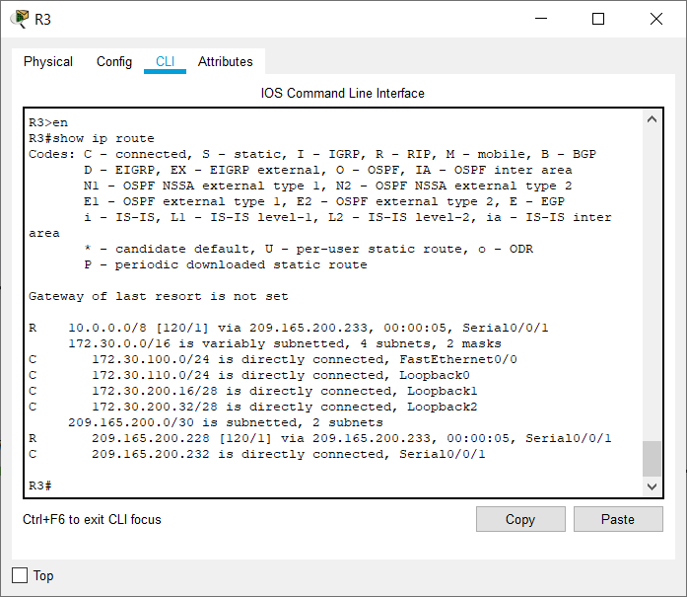

Figure 7.24 – Shows the IP routes of router R3

## Step 7: Examine the RIPv1 packets that are being received by R2.

Use the **debug ip rip** command to display RIP routing updates.

R2 is receiving the route 172.30.0.0, with 1 hop, from both R1 and R3. Because these are equal cost metrics, both routes are added to the R2 routing table. Because RIPv1 is a classful routing protocol, no subnet mask information is sent in the update.

## R2#debug ip rip

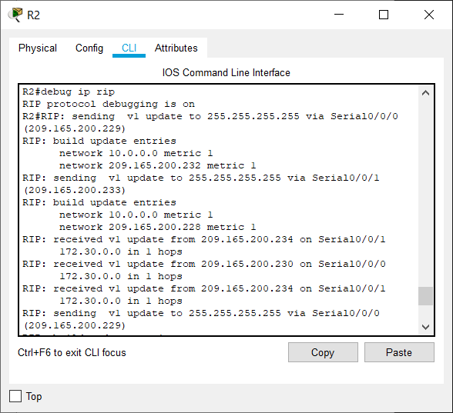

Figure 7.25 – The sending and receiving of routes in debug mode for router R2

R2 is sending only the routes for the 10.0.0.0 LAN and the two serial connections to R1 and R3. R1 and R3 are not receiving any information about the 172.30.0.0 subnet routes.

When you are finished, turn off the debugging.

R2#**undebug all**

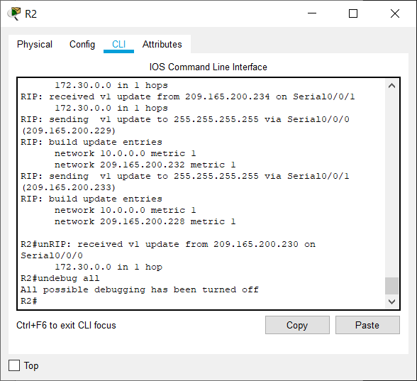

Figure 7.26 – Turning off debug mode using **undebug all** command

# Task 4: Configure RIP Version 2.

## Step 1: Use the version 2 command to enable RIP version 2 on each of the routers.

R2(config)#**router rip**

R2(config-router)#**version 2**

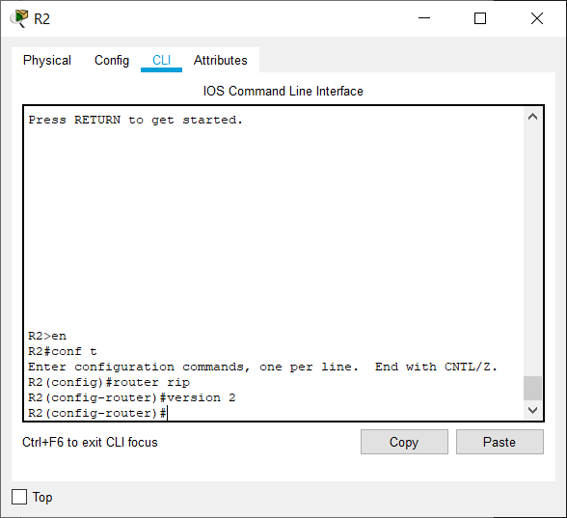

Figure 7.27 – Changing the version of RIP to version 2 for router R2

R1(config)#**router rip**

R1(config-router)#**version 2**

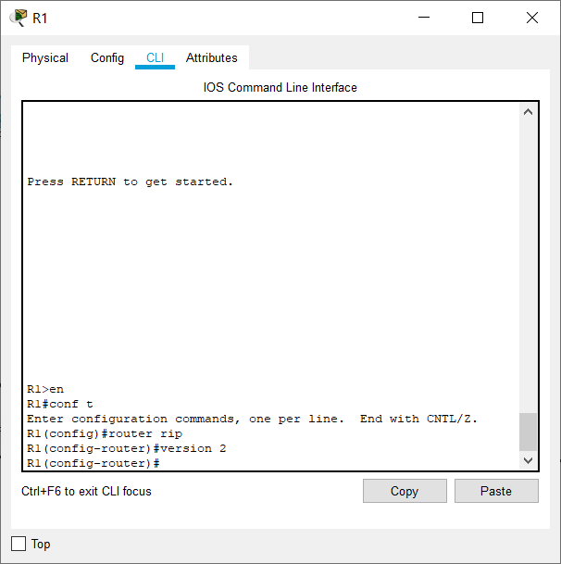

Figure 7.28 – Changing the version of RIP to version 2 for router R1

R3(config)#**router rip**

R3(config-router)#**version 2**

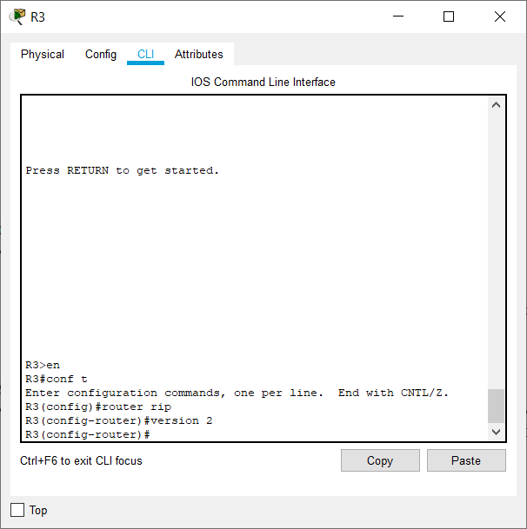

Figure 7.28 – Changing the version of RIP to version 2 for router R3

RIPv2 messages include the subnet mask in a field in the routing updates. This allows subnets and their masks to be included in the routing updates. However, by default RIPv2 summarizes networks at major network boundaries, just like RIPv1, except that the subnet mask is included in the update.

## Step 2: Verify that RIPv2 is running on the routers.

The **debug ip rip**, **show ip protocols**, and **show run** commands can all be used to confirm that RIPv2 is running. The output of the **show ip protocols** command for R1 is shown below.

## R1# show ip protocols

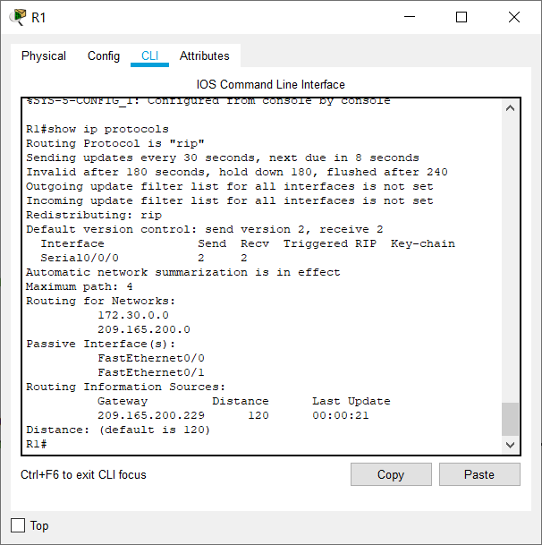

Figure 7.29 – Shows the IP protocols for router R1

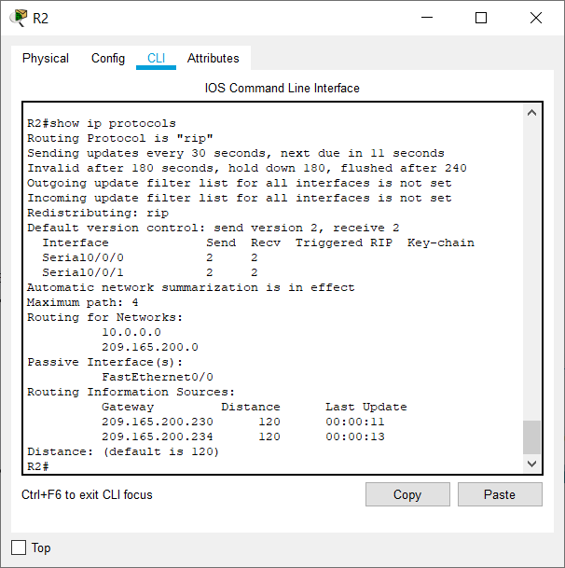

Figure 7.30 – Shows the IP protocols of router R2

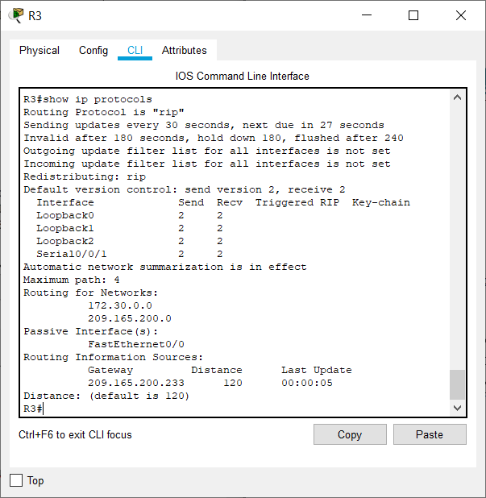

Figure 7.31 – Shows the IP protocols of router R3

# Task 5: Examine the Automatic Summarization of Routes.

The LANs connected to R1 and R3 are still composed of discontiguous networks. R2 still shows two equal cost paths to the 172.30.0.0/16 network in the routing table. R2 still shows only the major classful network address of 172.30.0.0 and does not show any of the subnets for this network.

## R2#show ip route

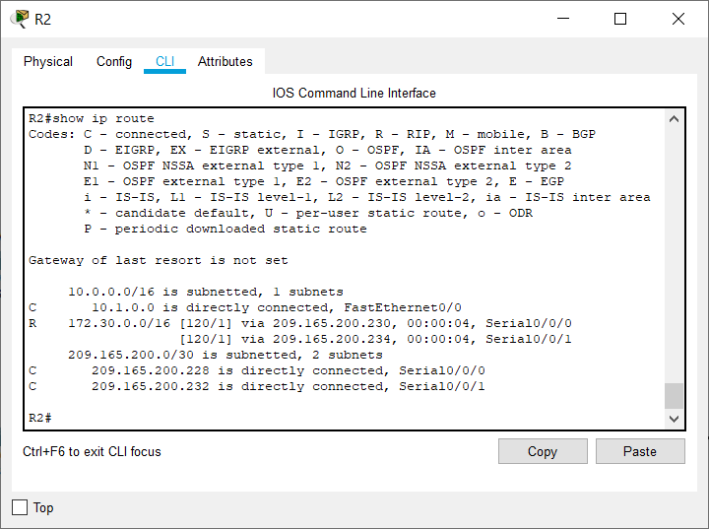

Figure 7.32 – Shows the IP routes for router R2

R1 still shows only its own subnets for the 172.30.0.0 network. R1 still does not have any routes for the

172.30.0.0 subnets on R3.

## R1#show ip route

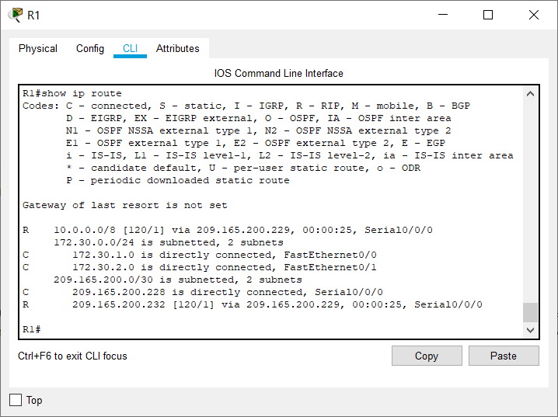

Figure 7.33 – Shows the IP routes for router R1

R3 still only shows its own subnets for the 172.30.0.0 network. R3 still does not have any routes for the

172.30.0.0 subnets on R1.

## R3#show ip route

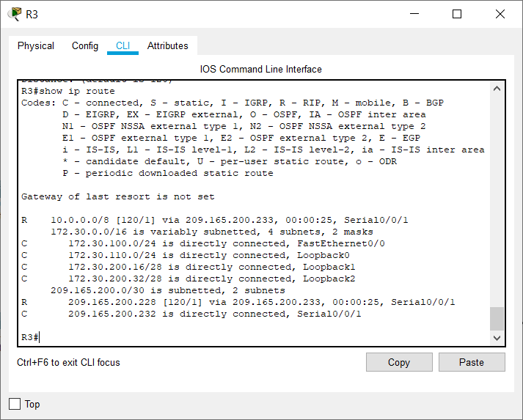

Figure 7.34 – Shows the IP routes for router R3

Use the output of the **debug ip rip** command to answer the following questions: What entries are included in the RIP updates sent out from R3?

1) 10.0.0.0/8

2) 172.30.100.0/24

3) 172.30.110.0/24

4) 172.30.200.16/28

5) 209.165.200.0/24

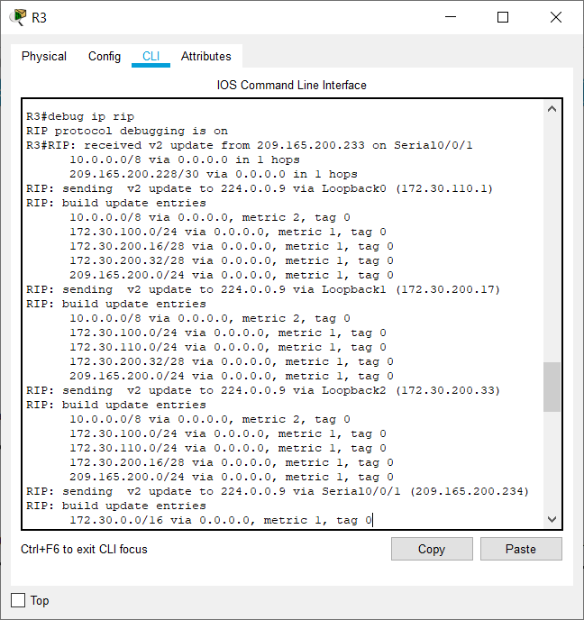

Figure 7.35 – Shows the sending and receiving of routes in debug mode for router R3

On R2, what routes are in the RIP updates that are received from R3? 172.30.0.0/16

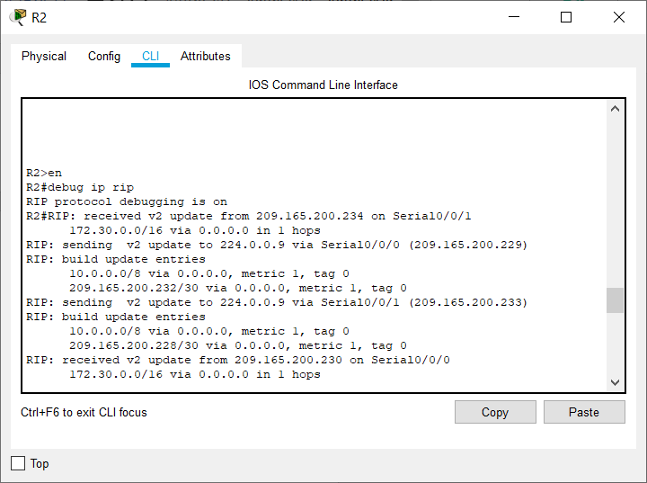

Figure 7.36 – Shows the sending and receiving of routes in debug mode for router R2

R3 is not sending any of the 172.30.0.0 subnets—only the summarized route of 172.30.0.0/16, including the subnet mask. This is why R2 and R1 are not seeing the 172.30.0.0 subnets on R3.

# Task 6: Disable Automatic Summarization.

The **no auto-summary** command is used to turn off automatic summarization in RIPv2. Disable auto summarization on all routers. The routers will no longer summarize routes at major network boundaries.

R2(config)#**router rip**

R2(config-router)#**no auto-summary**

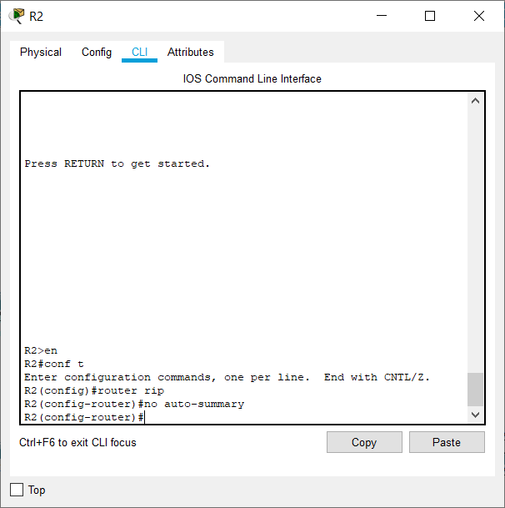

Figure 7.37 – Disabling automatic summarization for router R2

R1(config)#**router rip**

R1(config-router)#**no auto-summary**

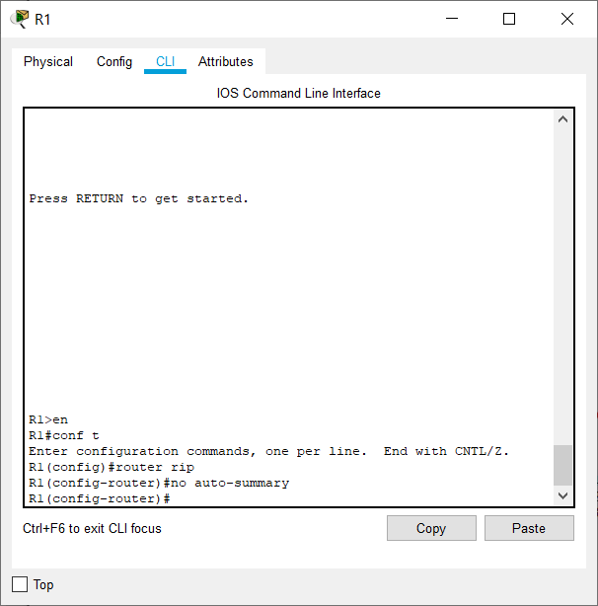

Figure 7.38 – Disabling automatic summarization for router R2

R3(config)#**router rip**

R3(config-router)#**no auto-summary**

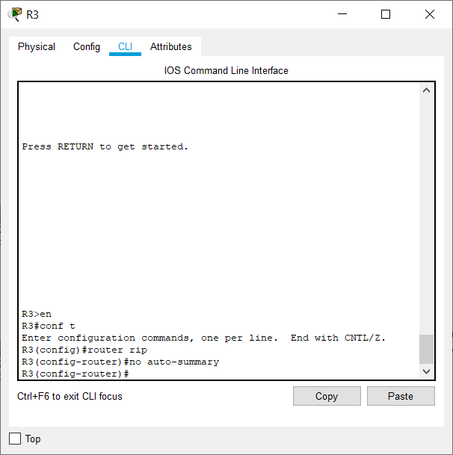

Figure 7.39 – Disabling automatic summarization for router R3

The **show ip route** and **ping** commands can be used to verify that automatic summarization is off.

# Task 7: Examine the Routing Tables.

The LANs connected to R1 and R3 should now be included in all three routing tables.

## R2#show ip route

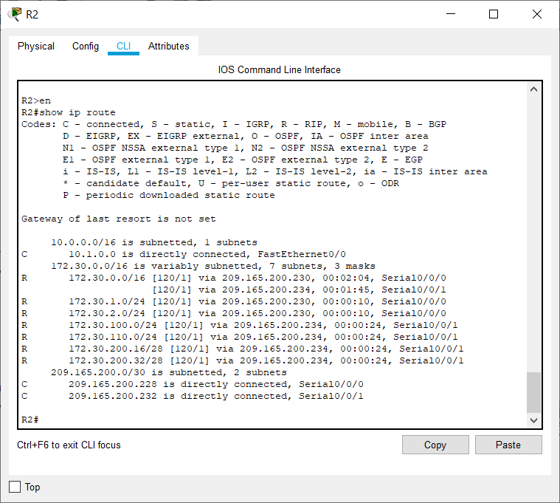

Figure 7.40 – Shows the IP routes for router R2

## R1#show ip route

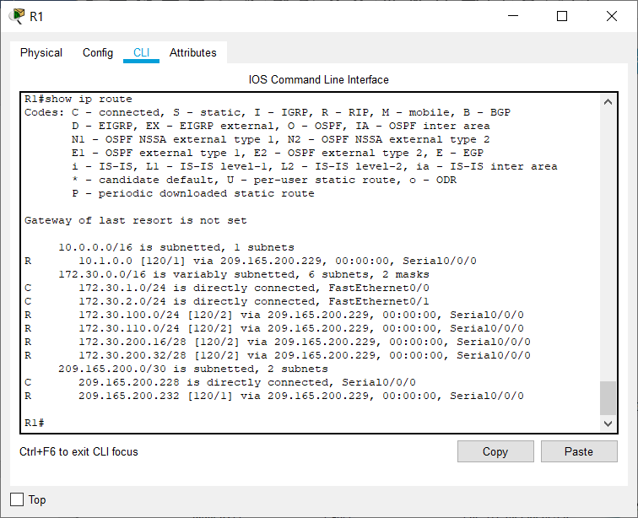

Figure 7.41 – Shows the IP routes for router R2

## R3#show ip route

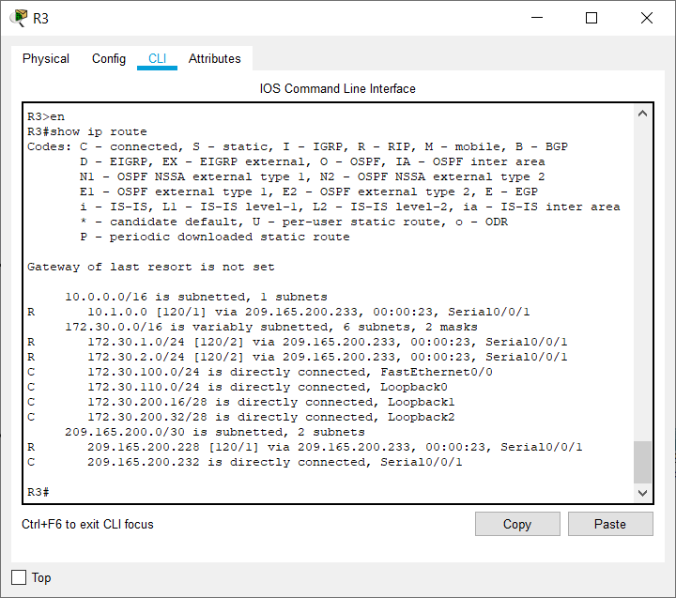

Figure 7.42 – Shows the IP routes for router R3

Use the output of the **debug ip rip** command to answer the following questions: What entries are included in the RIP updates sent out from R1?

172.30.1.0/24

172.30.2.0/24

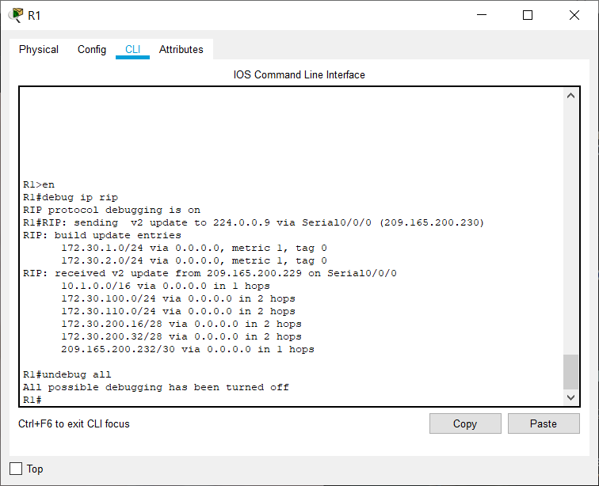

Figure 7.43 – Shows the output of **debug ip rip** for router R1

On R2, what routes are in the RIP updates that are received from R1?

172.30.1.0/24

172.30.2.0/24

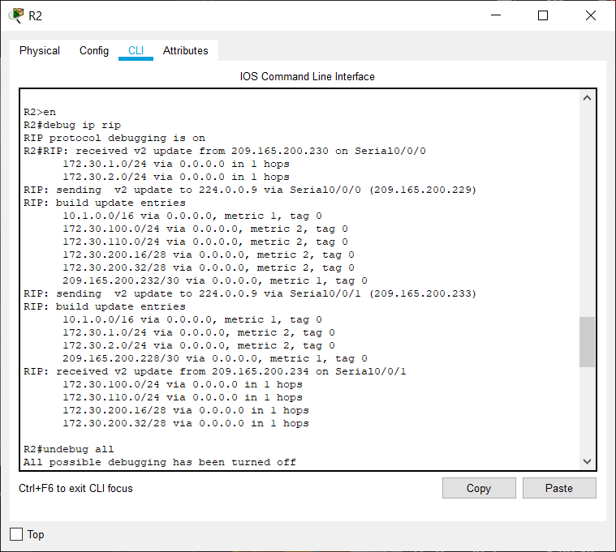

Figure 7.44 – Shows the output of **debug ip rip** for router R2 Are the subnet masks now included in the routing updates? Yes

# Task 8: Verify Network Connectivity.

## Step 1: Check connectivity between R2 router and PCs.

From R2, how many ICMP messages are successful when pinging PC1?

4 out of 5 messages are sent the first time followed by 5 out of 5 messages each time.

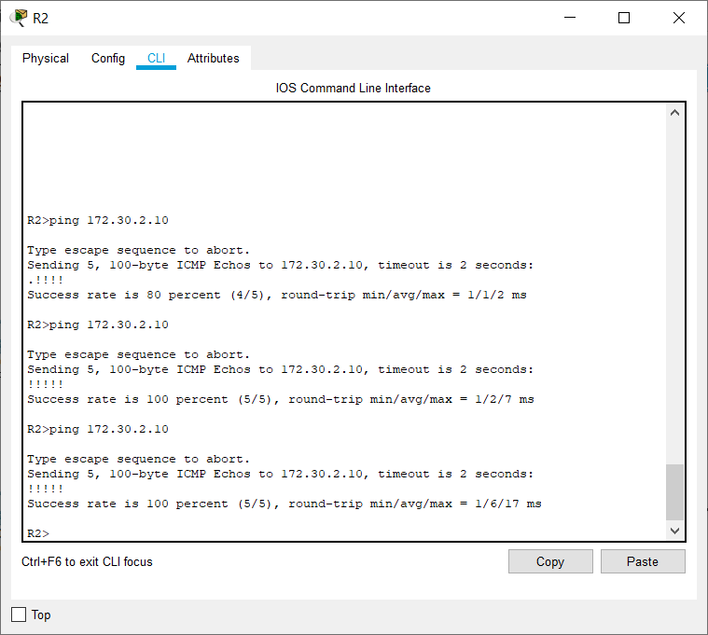

From R2, how many ICMP messages are successful when pinging PC4?

4 out of 5 messages are sent the first time followed by 5 out of 5 messages each time.

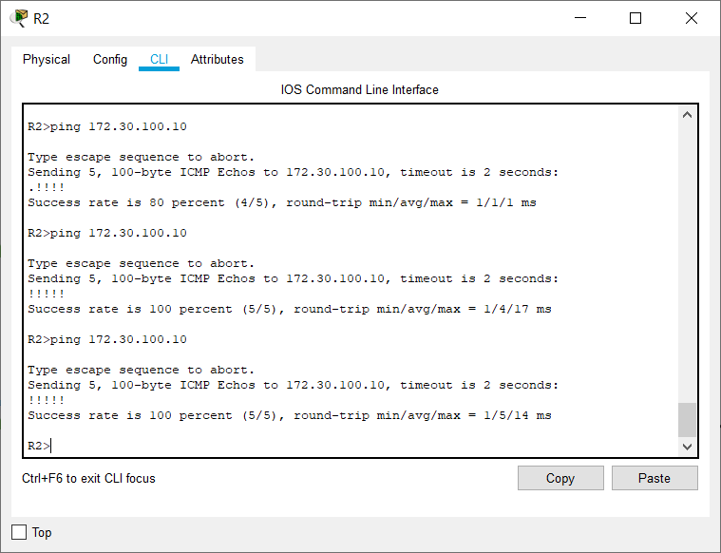

## Step 2: Check the connectivity between the PCs.

From PC1, is it possible to ping PC2? Yes What is the success rate? 100%

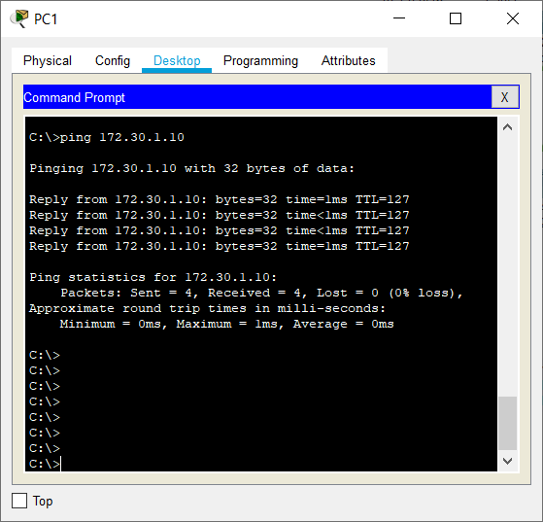

From PC1, is it possible to ping PC3? Yes

What is the success rate? 75% the first time, followed by 100%

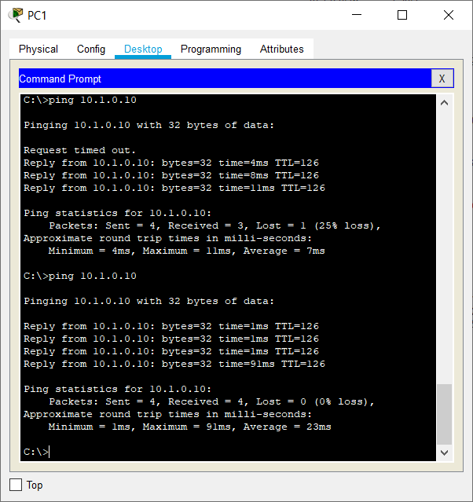

From PC1, is it possible to ping PC4? Yes What is the success rate? 100%

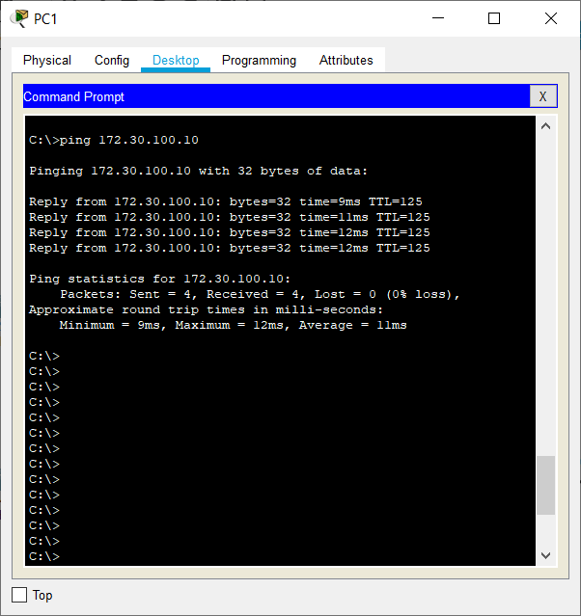

From PC4, is it possible to ping PC2? Yes

What is the success rate? 75% the first time, followed by 100%

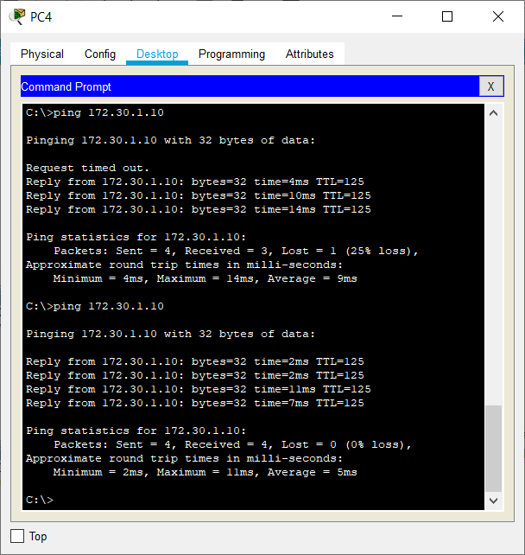

From PC4, is it possible to ping PC3? Yes What is the success rate? 100%

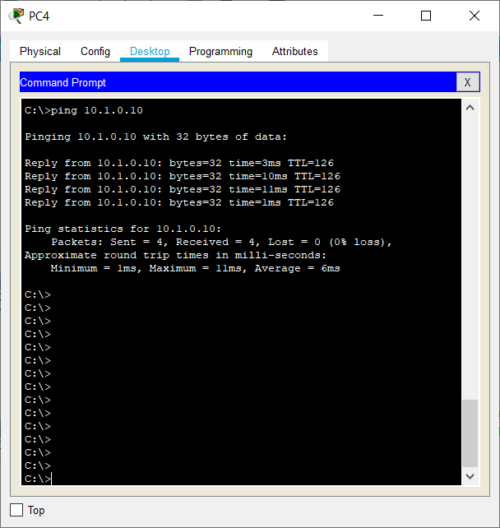

# Task 9: Documentation

On each router, capture the following command output to a text (.txt) file and save for future reference.

## show running-config

* **show ip route**
* **show ip interface brief**
* **show ip protocols**

All these outputs have been captured in txt files (named Router_R_command.txt where R can be R1, R2 and R3 and the commands are as above) and saved in the same folder as the document.

If you need to review the procedures for capturing command output, refer to Lab 1.5.1.

## show running-config For R1

**R1#show running-config**

Building configuration...

Current configuration : 885 bytes

!

version 12.4

no service timestamps log datetime msec

no service timestamps debug datetime msec no service password-encryption

!

hostname R1

!

!

!

!

!

!

!

!

no ip cef no ipv6 cef

!

!

!

!

!

!

!

!

!

!

!

!

spanning-tree mode pvst

!

!

!

!

!

!

interface FastEthernet0/0

ip address 172.30.1.1 255.255.255.0

duplex auto speed auto

!

interface FastEthernet0/1

ip address 172.30.2.1 255.255.255.0

duplex auto speed auto

!

interface Serial0/0/0

ip address 209.165.200.230 255.255.255.252

clock rate 64000

!

interface Serial0/0/1 no ip address

clock rate 2000000 shutdown

!

interface Vlan1 no ip address shutdown

!

router rip version 2

passive-interface FastEthernet0/0 passive-interface FastEthernet0/1 network 172.30.0.0

network 209.165.200.0 no auto-summary

!

ip classless

!

ip flow-export version 9

!

!

!

!

!

!

!

!

line con 0

!

line aux 0

!

line vty 0 4 login

!

!

!

end

**For R2**

**R2#show running-config**

Building configuration...

Current configuration : 831 bytes

!

version 12.4

no service timestamps log datetime msec

no service timestamps debug datetime msec no service password-encryption

!

hostname R2

!

!

!

!

!

!

!

!

no ip cef no ipv6 cef

!

!

!

!

!

!

!

!

!

!

!

!

spanning-tree mode pvst

!

!

!

!

!

!

interface FastEthernet0/0

ip address 10.1.0.1 255.255.0.0 duplex auto

speed auto

!

interface FastEthernet0/1 no ip address

duplex auto speed auto shutdown

!

interface Serial0/0/0

ip address 209.165.200.229 255.255.255.252

!

interface Serial0/0/1

ip address 209.165.200.233 255.255.255.252

clock rate 64000

!

interface Vlan1 no ip address shutdown

!

router rip version 2

passive-interface FastEthernet0/0 network 10.0.0.0

network 209.165.200.0 no auto-summary

!

ip classless

!

ip flow-export version 9

!

!

!

!

!

!

!

!

line con 0

!

line aux 0

!

line vty 0 4 login

!

!

!

end

**For R3**

**R3#show running-config**

Building configuration...

Current configuration : 1011 bytes

!

version 12.4

no service timestamps log datetime msec

no service timestamps debug datetime msec no service password-encryption

!

hostname R3

!

!

!

!

!

!

!

!

no ip cef no ipv6 cef

!

!

!

!

!

!

!

!

!

!

!

!

spanning-tree mode pvst

!

!

!

!

!

!

interface Loopback0

ip address 172.30.110.1 255.255.255.0

!

interface Loopback1

ip address 172.30.200.17 255.255.255.240

!

interface Loopback2

ip address 172.30.200.33 255.255.255.240

!

interface FastEthernet0/0

ip address 172.30.100.1 255.255.255.0

duplex auto speed auto

!

interface FastEthernet0/1 no ip address

duplex auto speed auto shutdown

!

interface Serial0/0/0 no ip address

clock rate 2000000 shutdown

!

interface Serial0/0/1

ip address 209.165.200.234 255.255.255.252

!

interface Vlan1 no ip address shutdown

!

router rip version 2

passive-interface FastEthernet0/0 network 172.30.0.0

network 209.165.200.0

no auto-summary

!

ip classless

!

ip flow-export version 9

!

!

!

!

!

!

!

!

line con 0

!

line aux 0

!

line vty 0 4 login

!

!

!

end

## show ip route For R1

**R1#show ip route**

Codes: C - connected, S - static, I - IGRP, R - RIP, M - mobile, B - BGP D - EIGRP, EX - EIGRP external, O - OSPF, IA - OSPF inter area N1 - OSPF NSSA external type 1, N2 - OSPF NSSA external type 2 E1 - OSPF external type 1, E2 - OSPF external type 2, E - EGP

i - IS-IS, L1 - IS-IS level-1, L2 - IS-IS level-2, ia - IS-IS inter area

* - candidate default, U - per-user static route, o - ODR P - periodic downloaded static route

Gateway of last resort is not set 10.0.0.0/16 is subnetted, 1 subnets

R 10.1.0.0 [120/1] via 209.165.200.229, 00:00:20, Serial0/0/0

172.30.0.0/16 is variably subnetted, 6 subnets, 2 masks C 172.30.1.0/24 is directly connected, FastEthernet0/0 C 172.30.2.0/24 is directly connected, FastEthernet0/1

R 172.30.100.0/24 [120/2] via 209.165.200.229, 00:00:20, Serial0/0/0 R 172.30.110.0/24 [120/2] via 209.165.200.229, 00:00:20, Serial0/0/0 R 172.30.200.16/28 [120/2] via 209.165.200.229, 00:00:20, Serial0/0/0

R 172.30.200.32/28 [120/2] via 209.165.200.229, 00:00:20, Serial0/0/0

209.165.200.0/30 is subnetted, 2 subnets

C 209.165.200.228 is directly connected, Serial0/0/0

R 209.165.200.232 [120/1] via 209.165.200.229, 00:00:20, Serial0/0/0

**For R2**

**R2#show ip route**

Codes: C - connected, S - static, I - IGRP, R - RIP, M - mobile, B - BGP D - EIGRP, EX - EIGRP external, O - OSPF, IA - OSPF inter area N1 - OSPF NSSA external type 1, N2 - OSPF NSSA external type 2 E1 - OSPF external type 1, E2 - OSPF external type 2, E - EGP

i - IS-IS, L1 - IS-IS level-1, L2 - IS-IS level-2, ia - IS-IS inter area

* - candidate default, U - per-user static route, o - ODR P - periodic downloaded static route

Gateway of last resort is not set 10.0.0.0/16 is subnetted, 1 subnets

C 10.1.0.0 is directly connected, FastEthernet0/0

172.30.0.0/16 is variably subnetted, 6 subnets, 2 masks

R 172.30.1.0/24 [120/1] via 209.165.200.230, 00:00:07, Serial0/0/0 R 172.30.2.0/24 [120/1] via 209.165.200.230, 00:00:07, Serial0/0/0

R 172.30.100.0/24 [120/1] via 209.165.200.234, 00:00:10, Serial0/0/1 R 172.30.110.0/24 [120/1] via 209.165.200.234, 00:00:10, Serial0/0/1 R 172.30.200.16/28 [120/1] via 209.165.200.234, 00:00:10, Serial0/0/1 R 172.30.200.32/28 [120/1] via 209.165.200.234, 00:00:10, Serial0/0/1

209.165.200.0/30 is subnetted, 2 subnets

C 209.165.200.228 is directly connected, Serial0/0/0 C 209.165.200.232 is directly connected, Serial0/0/1

**For R3**

**R3#show ip route**

Codes: C - connected, S - static, I - IGRP, R - RIP, M - mobile, B - BGP D - EIGRP, EX - EIGRP external, O - OSPF, IA - OSPF inter area N1 - OSPF NSSA external type 1, N2 - OSPF NSSA external type 2 E1 - OSPF external type 1, E2 - OSPF external type 2, E - EGP

i - IS-IS, L1 - IS-IS level-1, L2 - IS-IS level-2, ia - IS-IS inter area

* - candidate default, U - per-user static route, o - ODR P - periodic downloaded static route

Gateway of last resort is not set 10.0.0.0/16 is subnetted, 1 subnets

R 10.1.0.0 [120/1] via 209.165.200.233, 00:00:28, Serial0/0/1

172.30.0.0/16 is variably subnetted, 6 subnets, 2 masks

R 172.30.1.0/24 [120/2] via 209.165.200.233, 00:00:28, Serial0/0/1 R 172.30.2.0/24 [120/2] via 209.165.200.233, 00:00:28, Serial0/0/1

C 172.30.100.0/24 is directly connected, FastEthernet0/0 C 172.30.110.0/24 is directly connected, Loopback0

C 172.30.200.16/28 is directly connected, Loopback1 C 172.30.200.32/28 is directly connected, Loopback2

209.165.200.0/30 is subnetted, 2 subnets

R 209.165.200.228 [120/1] via 209.165.200.233, 00:00:28, Serial0/0/1

C 209.165.200.232 is directly connected, Serial0/0/1

## show ip interface brief For R1

**R1#show ip interface brief**

Interface IP-Address OK? Method Status Protocol FastEthernet0/0 172.30.1.1 YES manual up up FastEthernet0/1 172.30.2.1 YES manual up up Serial0/0/0 209.165.200.230 YES manual up up Serial0/0/1 unassigned YES unset administratively down down Vlan1 unassigned YES unset administratively down down

**For R2**

**R2#show ip interface brief**

|  |  |  |  |
| --- | --- | --- | --- |
| Interface | IP-Address | OK? Method Status | Protocol |
| FastEthernet0/0 | 10.1.0.1 | YES manual up | up |

FastEthernet0/1 unassigned YES unset administratively down down Serial0/0/0 209.165.200.229 YES manual up up Serial0/0/1 209.165.200.233 YES manual up up

Vlan1 unassigned YES unset administratively down down

**For R3**

**R3#show ip interface brief**

Interface IP-Address OK? Method Status Protocol FastEthernet0/0 172.30.100.1 YES manual up up FastEthernet0/1 unassigned YES unset administratively down down Serial0/0/0 unassigned YES unset administratively down down Serial0/0/1 209.165.200.234 YES manual up up Loopback0 172.30.110.1 YES manual up up Loopback1 172.30.200.17 YES manual up up Loopback2 172.30.200.33 YES manual up up

Vlan1 unassigned YES unset administratively down down

## show ip protocols For R1

**R1#show ip protocols**

Routing Protocol is "rip"

Sending updates every 30 seconds, next due in 4 seconds Invalid after 180 seconds, hold down 180, flushed after 240 Outgoing update filter list for all interfaces is not set Incoming update filter list for all interfaces is not set Redistributing: rip

Default version control: send version 2, receive 2 Interface Send Recv Triggered RIP Key-chain Serial0/0/0 2 2

Automatic network summarization is not in effect Maximum path: 4

Routing for Networks: 172.30.0.0

209.165.200.0

Passive Interface(s): FastEthernet0/0 FastEthernet0/1

Routing Information Sources:

Gateway Distance Last Update 209.165.200.229 120 00:00:10

Distance: (default is 120)

**For R2**

**R2#show ip protocols**

Routing Protocol is "rip"

Sending updates every 30 seconds, next due in 25 seconds Invalid after 180 seconds, hold down 180, flushed after 240 Outgoing update filter list for all interfaces is not set Incoming update filter list for all interfaces is not set Redistributing: rip

Default version control: send version 2, receive 2 Interface Send Recv Triggered RIP Key-chain Serial0/0/0 2 2

Serial0/0/1 2 2

Automatic network summarization is not in effect Maximum path: 4

Routing for Networks: 10.0.0.0

209.165.200.0

Passive Interface(s): FastEthernet0/0

Routing Information Sources:

Gateway Distance Last Update

|  |  |  |
| --- | --- | --- |
| 209.165.200.230 | 120 | 00:00:19 |
| 209.165.200.234 | 120 | 00:00:25 |

Distance: (default is 120)

**For R3**

**R3#show ip protocols**

Routing Protocol is "rip"

Sending updates every 30 seconds, next due in 12 seconds Invalid after 180 seconds, hold down 180, flushed after 240 Outgoing update filter list for all interfaces is not set Incoming update filter list for all interfaces is not set Redistributing: rip

Default version control: send version 2, receive 2

|  |  |  |  |
| --- | --- | --- | --- |
| Interface | Send |  | Recv Triggered RIP Key-chain |
| Loopback0 | 2 |  | 2 |
| Loopback1 | 2 |  | 2 |
| Loopback2 | 2 |  | 2 |
| Serial0/0/1 | 2 | 2 |  |

Automatic network summarization is not in effect Maximum path: 4

Routing for Networks: 172.30.0.0

209.165.200.0

Passive Interface(s): FastEthernet0/0

Routing Information Sources:

Gateway Distance Last Update 209.165.200.233 120 00:00:03

Distance: (default is 120)

# Task 10: Clean Up

Erase the configurations and reload the routers. Disconnect and store the cabling. For PC hosts that are normally connected to other networks (such as the school LAN or to the Internet), reconnect the appropriate cabling and restore the TCP/IP settings.

Task 10 is a good practice in real life where the devices are reused by engineers for different setups. In our case, it is not needed as we are in a simulation.